React/VUE client + Asp.net Core Web API + JWT

<https://jasonwatmore.com/post/2019/10/11/aspnet-core-3-jwt-authentication-tutorial-with-example-api>

JWT原理

<https://www.cnblogs.com/fiona-zhong/p/9951054.html>

JWT存Redis

<https://www.jianshu.com/p/dc89ca61d025>

NodeJS + React + JWT

<https://www.cnblogs.com/lidongyue/p/5269695.html>

这篇文章讲述了：

1：JWT存储在cookie、localStorage中的区别，XSS，XSRF攻击

JWT到底应该存在cookie，还是localStorage，还是session storage

<http://blog.itpub.net/10742815/viewspace-2142725/>

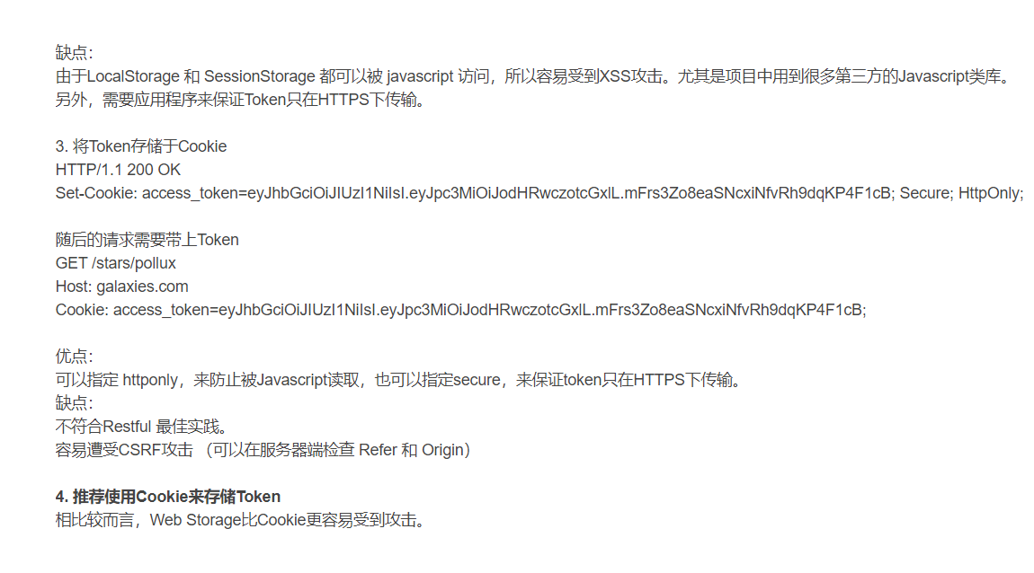

查了不少资料，都说localstorage不安全，放在cookie里面设置httponly比较好。